**TASK 1  
Data selected:** Austin Bikeshare Dataset **More information on the dataset:** <https://www.kaggle.com/datasets/jboysen/austin-bike?select=austin_bikeshare_stations.csvhttps://www.kaggle.com/datasets/jboysen/austin-bike?select=austin_bikeshare_stations.csv>  
 **SQL Queries written to analyze Austin bikeshare dataset.**

**Query 1: Peak Usage Time**  
Calculated peak usage times to identify hours with the highest activity. This query identifies the busiest hours for bikeshare usage, which is essential for resource allocation (e.g., increasing bike availability during peak hours) and operational planning.

**Query 2: Top 5 busiest stations**   
Found the top busiest stations. Understanding which stations handle the highest trip volumes helps identify key locations and evaluate station performance.

Query 3: Analyzed total trips, average trip duration, and the operational status of each station. This provided key performance metrics per station to gauge usage and efficiency. This query provides a comprehensive overview of station performance, including trip volume, average trip duration, and operational status. It helps assess not just how busy a station is but also how efficiently it is used.

**

**Schemas of New Tables created:**

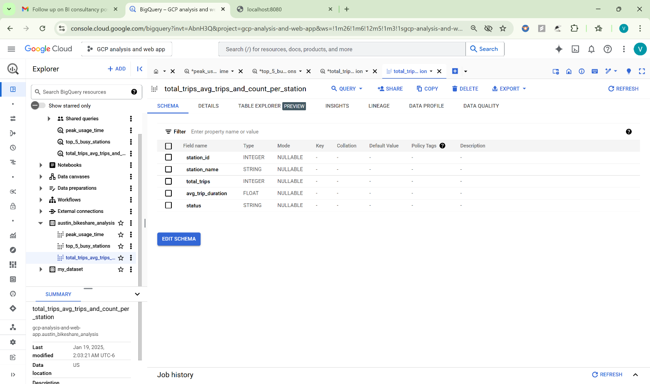

**Looker Dashboard:**

**Key Performance Indicators (KPIs):**Peak hours of bike usage.   
Top-performing stations in terms of trips.   
Average trip duration for each station.   
Operational status distribution (active vs. closed).

**Access to dashboard:** <https://lookerstudio.google.com/u/0/reporting/ebb92595-2ab6-4141-a25c-7593bb32efd6/page/KlDeE/edit>

**TASK 2: Creating a simple web app that writes data into tables in your BigQuery account.**A new table was designed and structured to store web app data

**Schema of the table**

**BigQuery Authentication & Access Setup:**The web app required authentication to access BigQuery. A JSON key file was generated and configured to provide the necessary role-based access permissions. **Key for the python code to access the credentials of big query role in JSON format**

**Python code to build the app using flask**

**Web app Interface**

Web App Link: <http://localhost:8080/>